create view employee_address

as

select e.EMPLOYEE_ID,e.FIRST_NAME,e.LAST_NAME,l.street_address,l.city

from employees e

inner join locations l

on e.LOCATION_ID=l.location_id;

select*from employee_address;

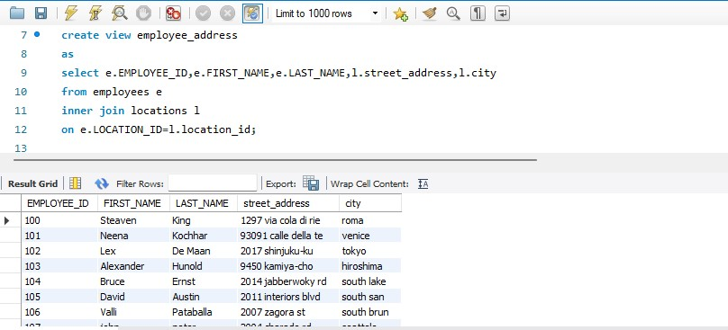

delimiter $$

create procedure emp_count(in job varchar(50))

begin

declare total int;

select count(EMPLOYEE_ID)

into total

from employees

where JOB_ROLE=job;

select total;

end$$

delimiter ;

call emp_count('clerk');

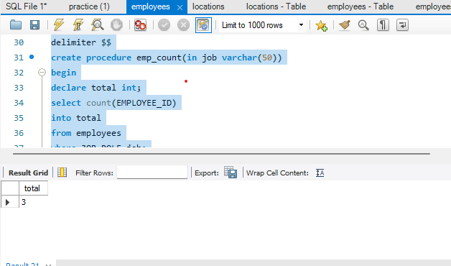

delimiter $$

create procedure emp_salary(inout emp_salary int)

begin

select SALARY into emp_salary from employees

where EMPLOYEE_ID=emp_salary;

end$$

delimiter ;

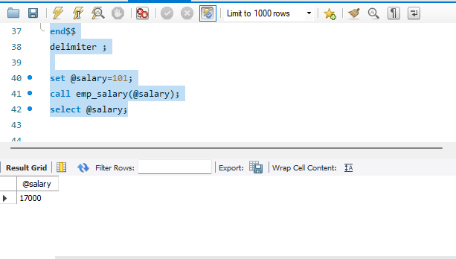set @salary=101;

call emp_salary(@salary);

select @salary;